**Level 1: PC Tower Case**

A close up of a map

Description generated with high confidence1.

3. a) The different version that are currently available a dual- or quad-core 2.8 GHz processor will likely serve you better than purchasing a single-core 3.4 GHz processor. This is because the two cores can simultaneously run two programs at 2.8 GHz, while the 3.4 GHz processor would have to divide its processing power, resulting in each program being theoretically limited to 1.7 GHz. The speed of memory is 16 GB of memory clocked at 800 MHz in a computer with a 1333 MHz FSB will result in lower performance than purchasing 8 GB of 1333 MHz memory.

b) When the older computers came out they only had memory about 4gb or 6gb which is almost the size of a phone nowadays. The older computers could only run the motion you provide it to do, meaning you could only play games and maybe if you’re lucky you run the browser. Nowadays, all the newer computers that come out to the market have a massive capacity, easily as much as 2 TB or 2000 GB, while solid-state drives (or SSDs) offer significantly less capacity. SSDs, however, operate significantly faster than traditional drives because they don’t have moving parts. One option is to install two drives in the computer: an SSD that stores the operating system and computer programs, and a traditional drive that stores your videos, music and documents.

4. a) Computer memory or random access memory (RAM) is your system’s short-term data storage; it stores the information your computer is actively using so that it can be accessed quickly. The more programs your system is running, the more memory you’ll need. They start off with 4GB, 6GB, 8GB, 16GB. They all are used for stores your videos, music and documents, it also depends on the amount of storage you need in a computer. If you plan to get a gaming computer you either need an 8GB or 16GB depends on the CPU performance about the system and the game you are playing.

**Level 2: Pc Motherboard**

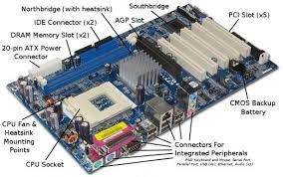

3. The 8088 is, for all practical purposes, identical to the 8086. The only difference is that it handles its address lines differently than the 8086. This chip was the one that was chosen for the first IBM PC, and like the 8086, it can work with the 8087-math coprocessor chip.

4. Ram memory is used for programs that are only in the system. The PC are different from older because you can do whatever you want to do on them for now and you can download anything with any blockage blocking you from not doing something that is not right or wrong. Moore’s law is the observation that the number of transistors in a dense integrated circuit doubles approximately every two years. It is used in the ram memory because the ram is a lot, so it will take a lot of years to fill up. Ram memory is different from existential memory because ram memory is when everything is save on your laptop or computer whereas external memory is when you save something on a different computer or hard drive. It is the speed of VGA or DDR and all the size of the rams are 4GB, 6GB, 8GB,16GB. VGA is basically used for computers or project to display video graphics on the screen. It was made in 1987. It was used to display your screen from a computer on the monitor or something like that. The connector that came before the VGA was the RCA. 3D graphics were introducing in 1987 and little before. The first 3D cards were S3 Virge. The memory depends on the speed of the video card.

**Level 3: Peripheral Devices**

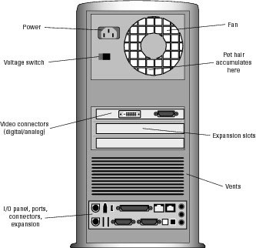

3. LCD displays have a native resolution, and running games (or the desktop) below that resolution degrades image quality due to the scaling process of enlarging the image. Using lower resolution modes isn't really a substitute for picking the right number of pixels in the first place. These days, any new desktop or laptop display with a native resolution below 1080p (1920x1080) is best avoided. 1080p has become the de facto standard for most PCs, with games and movies targeting the resolution. It's a good compromise that delivers reasonably sharp image quality at 24 inches and below, and you can still get excellent gaming performance even with modest hardware. Operating system is different than Software system because operating system is when what kind your system runs on like 32 bits or 64 bits. Software system is when you create a new software and you expand on that system. A dive computer, personal decompression computer or decompression meter is a device used by an underwater diver to measure the time and depth of a dive so that a safe ascent profile can be calculated and displayed so that the diver can avoid decompression sickness. A server is a computer program or a device that provides functionality for other programs or devices, called "clients". Servers can provide various functionalities, often called "services", such as sharing data or resources among multiple clients, or performing computation for a client.

4. External portable storage is when you either your regular PC storage gets full and portable storage device that can be attached to a computer through a USB or FireWire connection, or wirelessly. External hard drives typically have

high storage capacities and are often used to back up computers or serve as a network drive.